____.____.20____
LESSON number 7
REPRODUCTION OF ORGANISMS

Purpose: To study the processes of asexual and sexual reproduction of organisms, to understand the types of the sexual process, structural features and stages of formation of germ cells, and also to get acquainted with the biological aspects of human reproduction. Know the features of the formation of germ cells and their possible violations.
INDEPENDENT WORK
(Checking independent out-of-class work)
Basic concepts and provisions of the topic
(explain the concepts)
REPRODUCTION –
SEXUAL BREEDING –
SEXUAL REPRODUCTION –
DISPUTES–
SPOR EDUCATION –
VEGETATIVE BREEDING -
FRAGMENTATION -
EGG-
GAMETOGENESIS–
SPERMATOGENESIS
OVOGENESIS
OVOTIDA –
SPERMATOGONY –
FIRE –

Describe the process of parthenogenesis. What living organisms is it typical for?

Describe the conjugation process using the example of Spirogyra algae.

PRACTICAL PART

Work N. 1

Meiosis
MEIOSIS–
Opened:
Explain the essence of meiosis? What cells of the body is this process typical for?

What mechanisms during meiosis contribute to the manifestation of phenotypic and genotypic diversity of the species? Describe this process.
SCHEME OF MEIOSIS

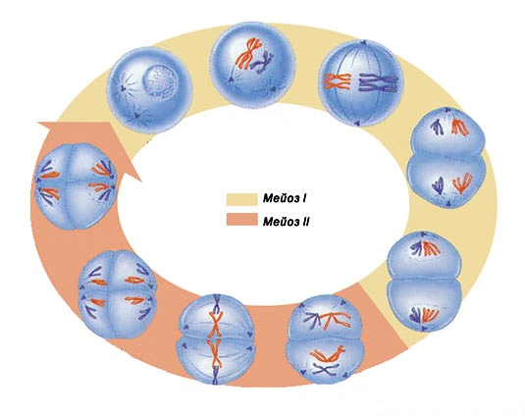

Meiosis I
Meiosis II

PROPHASE I MEIOSIS I

Leptotene –
Zygotena –
Paquitena –
Diplotena –
Diakinesis –

PHASES OF MEIOSIS I
Sketch the phases of meiosis I

Prophase I |  | Metaphase I |  | Anaphase I |  | Telophase I

Work N 2
Frog egg cage
Examine the specimen at a low magnification microscope
Magnification ___×___

1.
2.
3.

Work number 3
Ovary of a mammal (cat)
Examine the specimen at a low magnification microscope
1.
Magnification ___×___
2.
3.
4.
5.
6.

Work number 4
Mammalian ovum (cat)
1.
Magnification ___×___
2.
3.
4.
5.
6.

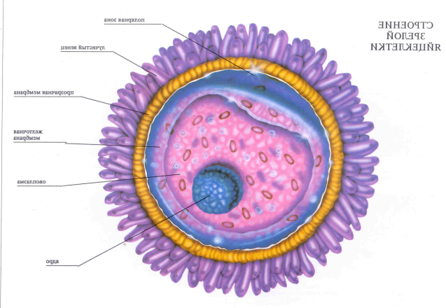
1.
2.
3.
4.
5.
6.

Work number 5
Male rat sex glands
Examine and sketch the gonads of a male rat
Magnification ___×___

1.
2.
3.
4.

Work number 6
Human sperm
Magnification ___×___
1.
2.
3.
4.
5.
7.
6.
5.
4.
3.
2.
8.
1.

12.
11.
10.
9.

Human sperm

Work number 7
Guinea pig sperm
Magnification ___×___

1.
2.
3.
4.

Work number 9
Rooster sperm
Magnification ___×___

1.
2.
3.
4.

Work number 8
Gametogenesis
Sign the main stages of gametogenesis and the number of chromosomes
in the cell (n,c)

SPERMATOGENESIS

OOGENES

Make a comparative description of mitosis and meiosis (a), indicate their biological significance (b), explain what practical significance these processes have for the future doctor.
а)
b)
c)

