U.D.C.618.179-084-055.25
PREVENTION OF REPRODUCTIVE HEALTH PROBLEMS AMONG ADOLESCENT GIRLS
Gordiets Anastasia Victorovna, Galaktionova Marina Yur'evna,
Maiseenko Dmitrii Aleksandrovich
Prof. V.F. Voino-Yasenetsky Krasnoyarsk State Medical University, Krasnoyarsk, Russian Federation
Summary: The article describes the experience of the volunteer work of medical university students with teen girls in schools in the prevention of reproductive health problems. The article describes an example of the organization of a health lesson "I am a girl and a future mother!" by the students under the guidance of teachers, pediatricians and obstetricians. For the first time in our medical school students performed volunteer work with teenagers in schools in the district territory within the framework of an all-Russian patriotic action "Snow landing", dedicated to the 70th anniversary of Victory in the Great Patriotic War.
Keywords: volunteers, students, schoolgirls, reproductive health.
Relevance. In Russia, the incidence of gynecological diseases varies from 10 to 35% [1]. The deterioration of the health of adolescent girls that form the reproductive potential of the nation is of particular concern in recent decades. Therefore, nowadays special attention is paid to issues of adolescent reproductive health, because according to the "The concept of Russian demographic development for the period until 2015" reproductive health is exactly the factor that will determine the reproduction of the population [2,3,4].
Reproductive health of women is formed in childhood and adolescence. Formed physical development, especially during puberty, and past medical history have further significant impact on the course of pregnancy and childbirth, and the disorders of sexual development and menstrual function during the puberty are often the causes of deterioration of the reproductive function and infertility [5,6,7].
Health education can be individual, group and collective. It includes the promotion of preventive measures aimed at creating a need for a healthy lifestyle and orienting young people and their parents on understanding the harm "of risky" or so-called "self-destructive" behavior (smoking, alcohol abuse, drug addiction, substance abuse, early sexual activity, juvenile delinquency, vagrancy, etc.) [8].
Nowadays almost 18% of children aged 10-11 and over 60% of 16-17 year olds smoke (boys – 25,4%, girls – 20,9%). It turns out that smoking by teenage girls more than 5 cigarettes a day for 5 years is comparable with the removal of one ovary. Smoking can cause infertility and adverse pregnancy with the development of anemia, gestosis and violations of labor, not to mention the condition of the fetus. About 40% of 10-11 year-olds and more than 72% of those over 13 years old consume alcoholic beverages (including low alcohol drinks). By age 30, these young people can become chronic disabled [9].
Therefore, to date, it has been proved that the formation of the reproductive system in girls occurs in the luteal phase deficiency conditions. And in the first years after menarche 80% of girls have anovulation. However, recently the frequency of disorders of menstruation rhythm increased in the group of 10-14 year old girls, and 15-17 year old girls, which requires medical correction [10.11].
An important cause of the neglect on contraception and reproductive health is the low competence of information sources.
Purpose. Study of the literature data on the reproductive health of adolescent girls. Mastering the health education methods with adolescents.
Materials and methods. The consultation of adolescent girls in the schools of settlements of Nizhne-Ingashsky District, Krasnoyarsk Krai during the winter holidays in February 2016. The event was organized by the student headquarters of Krasnoyarsk SMU supported by the university administration and the administration of Nizhne-Ingashsky District within the framework of a patriotic action "Snow landing."
Results and conclusions. Within the framework of "Snow landing" action 10 settlements of Nizhne-Ingashsky District, Krasnoyarsk Krai were visited. In each settlement the meetings with the population and the children of Grades 7-11were held. For the teenage girls the reproductive health lesson was conducted: the present situation on the health of girls, the need for regular medical surveillance and for observance of healthy lifestyle were explained. Girls were given a lot of visual materials: menstrual calendars, girls’ personal hygiene rules and sexual security rules etc. (Photos 1 and 2).
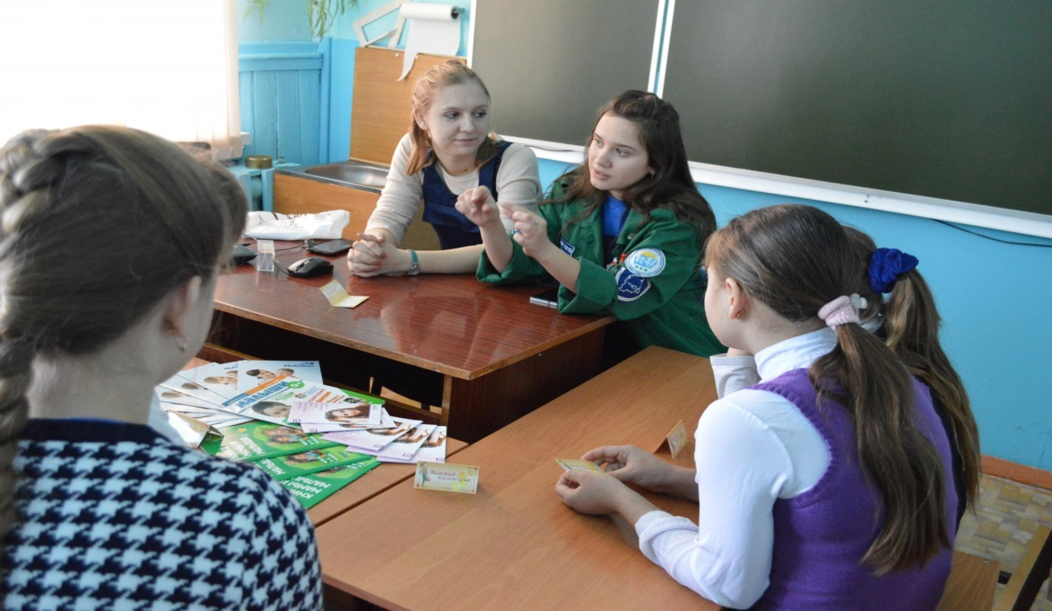

Photo 1. Conducting sanitary educational work with schoolgirls.

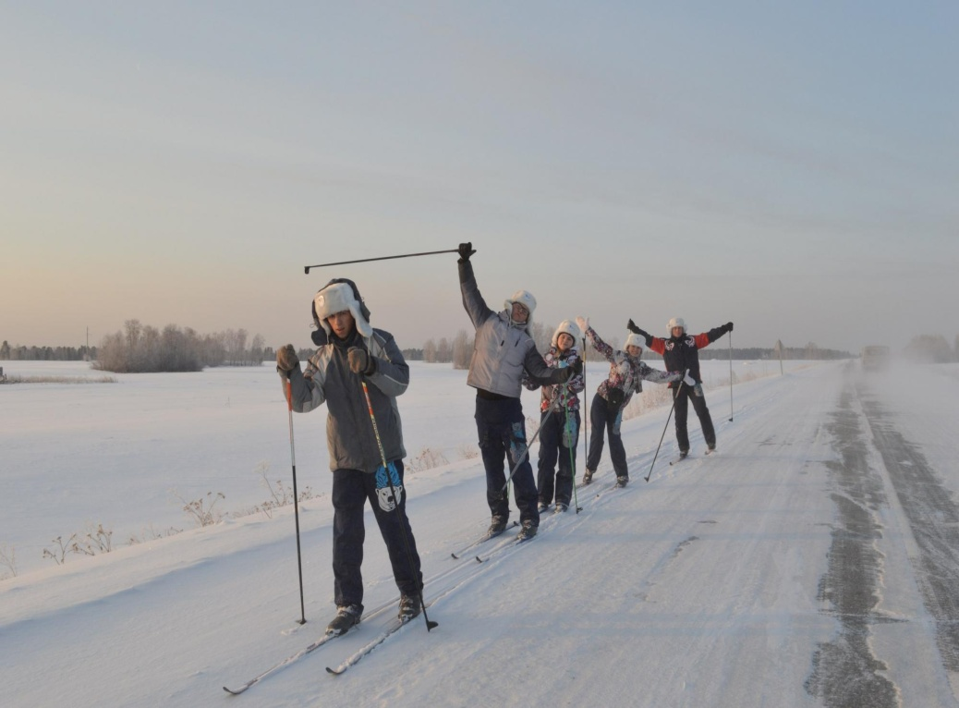

Photo 2. Skiing between the settlements in Nizhne-Ingashsky District.

The following is a plan of the health lessons for schoolgirls of 12-17 years, «I am a girl and a future mother!». The duration of the lesson is 45 minutes. Required equipment and materials - multimedia projector, laptop, videos, presentation, printed materials for distribution.
- Introduction. Explanation of the relevance of the problem of preservation of women’s reproductive health (presentation). 10 minutes.
- A brief review of the anatomy and physiology of female reproductive organs (presentation). 5 minutes.
- Showing the video «How to wash properly - intimate hygiene» (Produced with the scientific mentoring by the honored science worker of the Russian Federation Prof. Razinskiy V.E. (RUDN) (available at https://ok.ru). 2,40 minutes.
- Showing the video «Hygiene of girls» (School of Dr. Komarovsky) (available at www.youtube.com). 9 minutes.
- Showing the video «Personal hygiene during menstruation» (available at www.youtube.com). 2 minutes.
- Explaining how to use a menstrual calendar. Giving handouts (menstrual calendars). 5 minutes.
- Rules to be observed when discussing the beginning of a sexual life with a teenager. 10 minutes.
Thus, the collaboration of the students’ volunteer movement and the teaching staff of the university for the events of this format demonstrates the advisability of conducting classes on the basics of a healthy lifestyle with the inclusion of issues of reproductive health starting with the high-school students and the first-year students of higher educational institutions, thereby laying the basis for the future happy motherhood.
References
- Semyatov S.M. Reproductive health of adolescent girls in the Moscow metropolis in modern socio-economic and environmental conditions: Abstract of the MD thesis. 2009.
- Maiseenko D.A. Tsaryuk E.P., Semenova Yu.E. Gynecological morbidity in teenage girls being treated in children's physical offices at the multidisciplinary hospital // Russian Medical Journal. 2015. №20. P. 1217-1220.
- Egorova A.T., Shapranova E.D., Maiseenko D.A. et al. Reproductive behavior and health of female students of KrasGMU // Siberian Medical Review. 2011. №1. P. 67-70.
- Kalashnikova I.V., Orlova V.S., Kurganskaya G.M. Disorders of menstrual function in a population of adolescent girls // Scientific Journal of Belgorod State University. Series: Medicine. Pharmacy. 2010. № 9. P. 18-26.
- Jayarajah CG, Seneviratne T. Development of a mother and baby unit contraception assessment tool. Arch Women's Ment Health. 2016;19(6):1129-40.
- Bitzer J, Abalos V, Apter D, Martin R, Black A, Machado RB, Cheng L, Ling X, Skouby S, Affandi B, Nappi RE, Lee JR, Suturina L, Kaunitz A, Jensen J. Targeting factors for change: Contraceptive counselling and care of female adolescents. Eur J Contracept Reprod Health Care. 2016;21(6):417-30.
- Heywood W, Pitts MK, Patrick K, Mitchell A. Fertility knowledge and intentions to have children in a national study of australian secondary school students. Aust New Zealand J Public Health. 2016;40(5):462-7.
- Bases of children's health formation: a collection of guidelines to practical training for students of the specialty 060103.65 - Pediatrics (full-time) / Compiled by A.V. Gordiets, M.Yu. Galaktionova, E.I. Prakhin [et al.]. - Krasnoyarsk: KrasGMU, 2015. - 266 p.
- Donnelly J, Horn RR, Young M, Ivanescu AE. The effects of the yes you can! curriculum on the sexual knowledge and intent of middle school students. J Sch Health. 2016;86(10):759-65.
- Bersamin M, Fisher DA, Marcell AV, Finan LJ. Reproductive health services: Barriers to use among college students. J Community Health. 2016:1-5.
- Breuner CC, Mattson G. Sexuality education for children and adolescents. Pediatrics. 2016;138(2).
Authors
Gordiets Anastasiya Victorovna Prof. V.F. Voino-Yasenetsky Krasnoyarsk State Medical University, Krasnoyarsk, Russian Federation, Address: 1, PartizanZheleznyak Str., Krasnoyarsk, Russian Federation 660022; Phone +7(391)2200462; e-mail: gordiezav@yandex.ru
Galaktionova Marina Yur'evnaProf. V.F. Voino-Yasenetsky Krasnoyarsk State Medical University, Krasnoyarsk, Russian Federation, Address: 1, PartizanZheleznyak Str., Krasnoyarsk, Russian Federation 660022; Phone +7(391)2200462; e-mail: myugal@mail.ru
Maiseenko Dmitrii Aleksandrovich, Prof. V.F. Voino-Yasenetsky Krasnoyarsk State Medical University; Address: 1, PartizanZheleznyak Str., Krasnoyarsk, Russian Federation 660022; Phone +7(391)2642983; e-mail: dmitrij.maiseenko@pochta.ru

