Health care is improving.

- Read and find in the text sentences with verbs in Present Simple, Present Continuous, and Present Perfect. Explain their using.

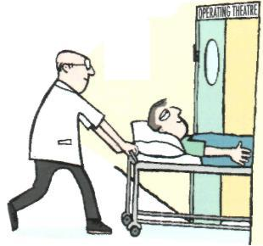
Health care is improving everywhere. Additional kinds of facilities, such as clinics, are being built every day. Still, the hospital remains the most prominent health care agency. Small clinics usually cannot afford to maintain all the sophisticated equipment now available for treatment.
Hospitals do not have unlimited bed space for patients. In fact, many hospitals are unable to accommodate all of their patients. As a result, more and more hospitals are developing outpatient or extended care facilities. Rather than enter as an inpatient, the patient visits the hospital only if further diagnosis or treatment is necessary. In this way, patients who do not require the regular supervision of the hospital staff can still benefit from the facilities available at the hospital. In addition, beds can be reserved for the acutely ill. Patients may even save as much as half of the money they would normally have to pay for inpatient treatment.
Patients who use outpatient services are usually ambulatory, or able to walk. Among them are persons who have just completed a hospital stay during the acute phase of an illness and who need some follow-up treatment. Patients hospitalized for a stroke or a heart attack fall into this category. The elderly also are making greater use of various forms of extended care facilities. Medical advances enable people to live longer, but they often have chronic health problems - such as high blood pressure or rheumatism - that require constant supervision but not hospitalization.
Facilities for self-care patients are also included in the outpatient centers. Included are the diabetic learning to give himself insulin; the post-coronary patient trying to adjust to a new pace of life, and the patient requiring regular x-ray therapy. Each kind of patient is encouraged to live as normal a life as possible, using the hospital's facilities only when necessary. This concept is known as progressive hospital care.

2. Translate the following words.
Prominent, health care agency, concept, constant supervision, accommodate, afford,
sophisticated equipment, advances, available, bed space, follow-up treatment.

3. Fill in the correct word: maintain, accommodate, save, remains, follow-up treatment, facilities

- Additional kinds of … are being built.
- Hospital … the most prominent health care agency.
- Clinics cannot afford to … all the sophisticated equipment.
- Hospitals are unable to … all of their patients.
- Patients may … as much as half of the money.
- They need some …

4. Express your opinion about the advantages and disadvantages of outpatient services.
Use the expressions below.
I think, I believe, I disagree, However, I have to admit, On the other hand, One advantage is, Another advantage is, Moreover, Furthermore, etc.

