- Complete the table:
 | Name of element | Biological function | Deficiency symptoms
H₂O
Na
K
Cl
Са
Р
Fe
Cu
Mg
Zn

- Answer the questions using diagrams:
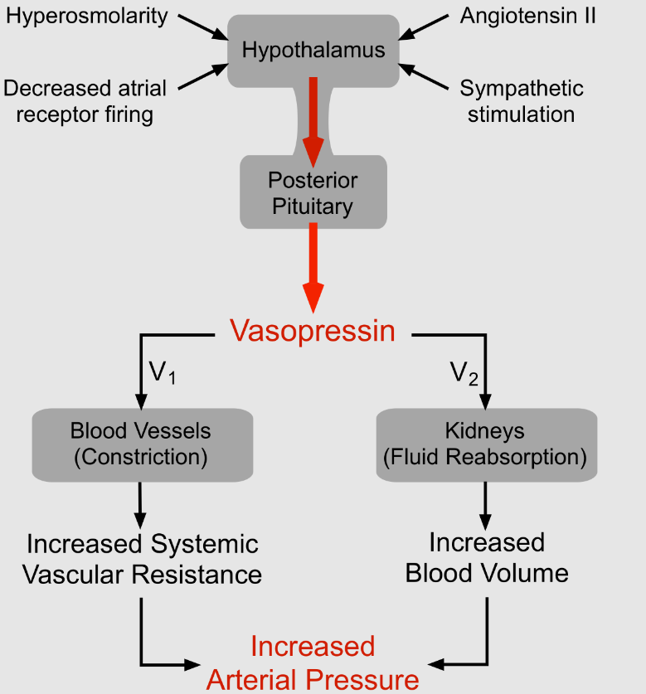
- Which organ synthesizes and released vasopressin?
- What is the stimulus for the release of vasopressin?
- What are the target cells of vasopressin?
- What is the function of vasopressin?
- What other hormones help maintain blood pressure and blood volume?
- What hormone reduces blood pressure and blood volume?

- Describe the regulation of blood volume in blood loss using the diagram:

Blood loss -> drop in blood pressure -> ....

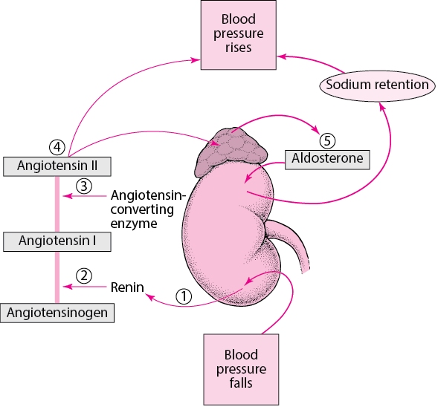

- Describe the regulation of calcium and phosphate in hypocalcemia using the diagram:

Decreased calcium -> low calcium level is sensed by parathyroid cells -> …
