[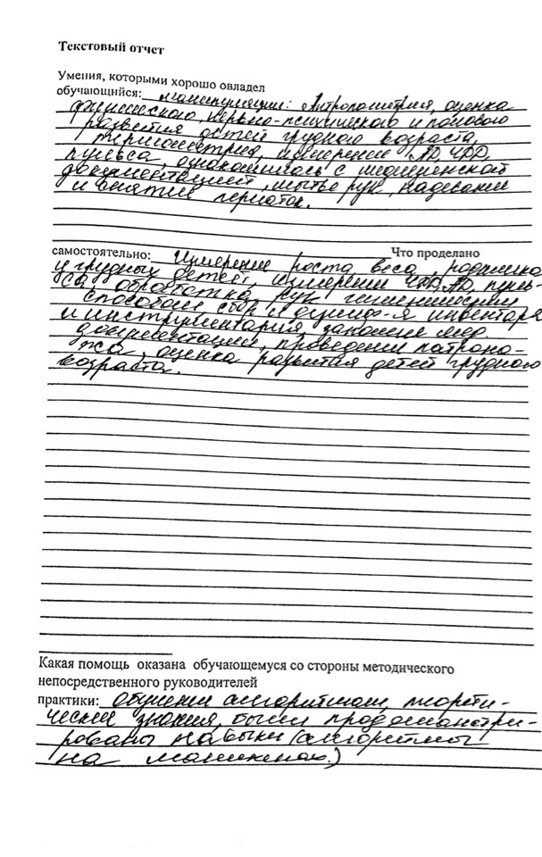](https://vk.com/photo439715471_456257490)[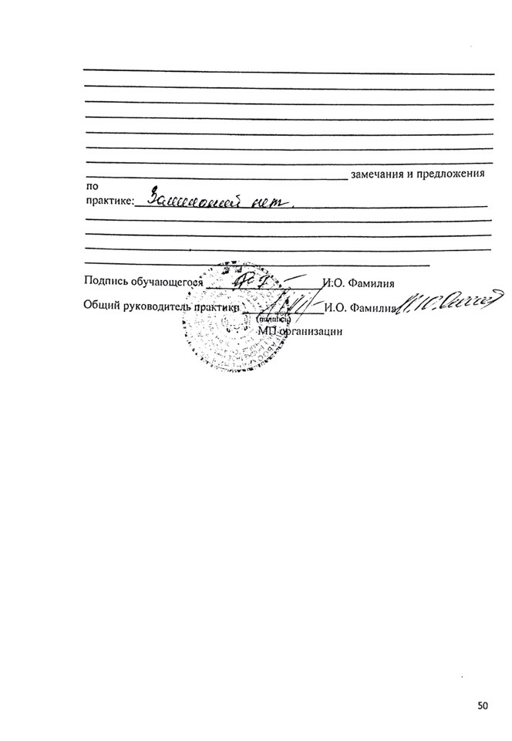](https://vk.com/photo439715471_456257491)