Please answer the following questions in writing and attach a photo of the answer (put all photos in one file and attach to the assignment: you can collect all the files in a blank MS Word document without borders, put all the photos in sequential order; rotate the images for ease of reading, if it is necessary so that there are no images "sideways" and attach the file either in this format, or resave it in pdf).

Deadline: today 23.00

**№1** (for Abouabdalla Mahmoud Saad Abdalla Ali, Asma Mahamat Tahir Abakar, Elgamal Ithar Mohamed Yussef Ali, Mohamed Hossam Mostafa Kamal, Refaey Ahmed Mohamed Moustafa )

1. Vitamins A and D can be used once in a dose, ensuring their normal content in the body in the next few weeks. Vitamins of group B (B1, B2, PP, B6, etc.) must be obtained daily. What is the reason for this?
2. Why vitamin C deficiency leads to anemia?
3. What vitamin is needed in predominantly carbohydrate diet? Why?
4. Toxicity of what vitamin causes: Raised blood calcium, calcification of blood vessels and heart tissues, calcification of tooth soft tissues, thinning of tooth enamel, excessive thirst, headaches, irritability, loss of appetite, weakness, nausea, kidney stones, calcification of soft tissues (kidneys, lungs, joints), and mental and physical retardation of offspring? Why the excess of this vitamin can lead to the appearance of these symptoms?

5. The figure shows water-soluble vitamins.

А. Name vitamins which present at this picture

B. Name coenzymes that can be formed by these vitamins.

C. Name functions of these coenzymes and pathways in which they take part.

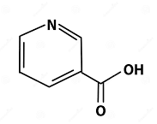

**№2** (for Al-ahmar Adnan Othman Ahmed Ali, Babaicheshmehmaki Armin Sadollah, Fahmi Abdelrahman Mohamed Talaat, Purtaheri Mahla Ali, Salem Ahmed Imad Abdellatif Mohamed)

1. At the end of the 19th century and at the beginning of the 20th century, pellagra was a fairly common disease, especially in rural areas where people used to eat little meat, and mainly fed on maize. Explain why such a diet led to a deficiency of nicotinic acid?

2. Why folic acid and vitamin B12 deficiency leads to megaloblastic anemia?

3. What vitamin is needed in predominantly protein diet? Why?

1. What vitamin deficiency might lead to failure in wound healing; a failure in the formation of teeth; and failure in the absorption of the intestinal iron? Why the deficiency of this vitamin can lead to the appearance of these symptoms?

5. The figure shows water-soluble vitamins.

А. Name vitamins which present at this picture

B. Name coenzymes that can be formed by these vitamins.

C. Name functions of these coenzymes and pathways in which they take part.

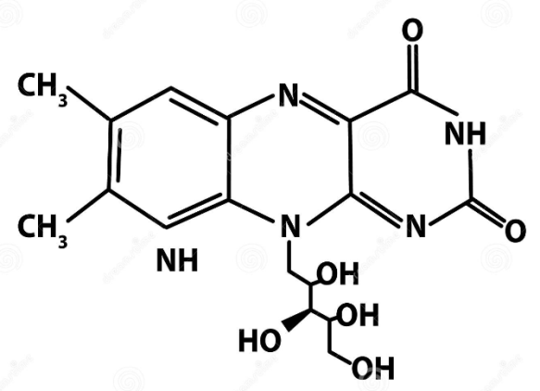

**№3** (for Alsavi Omar Haled Abdelmavla, Delshad Farid Faroh, Farzanegan Farzan Farzad, Rabi Moamen Elsaed Hassan Yossef, Zamani Mohammadamir Ashraf)

1. Daily requirement of nicotinic acid (vitamin PP) is 7,5 mg for adults, and it decreases if diet contains high quantity of tryptophan. What can be suggested under this observation about interconnection between nicotinic acid and tryptophan?

1. Why vitamin C deficiency leads to bleeding?

3. Hypoenergetic condition can be developed at the deficiency of vitamin B1. Explain, what reactions of the general path of catabolism are disordered at hypovitaminosis B1. Name the coenzyme formed by vitamin B1

4. Why eating a large number of raw eggs can be accompanied by dermatitis, seborrhea, impaired function of the peripheral nervous system?

5. The figure shows water-soluble vitamins.

А. Name vitamins which present at this picture

B. Name coenzymes that can be formed by these vitamins.

C. Name functions of these coenzymes and pathways in which they take part.

