Many, much, a few, a little
We can use many, much, a few and a little to talk about quantity.

Many
With countable nouns, mainly in questions and negatives:
He doesn’t have many friends.
Do many people know about this?
How many people know about it?

Much
With uncountable nouns, mainly in questions and negatives:
I don’t have much time.
Is there much interest in this?
How much information do you need?

A few
With countable nouns, mainly in positives and questions
There were only a few people at his presentation.
Could you give me a few more ideas?

A little
With uncountable nouns, mainly in positives and questions:
I get by with a little help from my friends.
Can you give me a little more information?

Exercises
1. Поставьте «+» при правильном использовании «much» или «many», поставьте «-» - при неверном.
- We haven’t many food in the house.
- I have not many information about the company.
- I need much apples for the pie.
- How many people are there in your office?
- There is much wine in the bottle.
- She has not many luggage.
- My son has much money now.
- There is many snow in the mountains.
- He was in London many times in his life.
- John has much exams.

2. Используйте «much» или «many» для выражения «Сколько…?».
- How … days?
- How … sugar?
- How … cigarettes?
- How … work?
- How … petrol?
- How … children?
- How … theatres?
- How … juice?
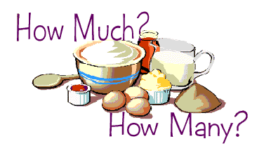
3. Поставьте «a lot of» (много) в необходимом месте в предложении. Переведите.
- There are interesting people at the party.
- There is fish for lunch.
- She has nice shoes for summer.
- They have problems in their business.
- There is water in the bath.

4. Перепишите вопросы, заменив some на «a little» или «a few».
- Would you like some cheese?
- Would you like some mineral water?
- Would you like some strawberries?
- Can I offer you some black coffee?
- Can I offer you some bread?
- Shall I bring you some biscuits?
- Shall I bring you some plums?
- Would you like some meat?

5. Поставьте подходящее слово из скобок.
- There is too … (much/many/a few) salt in the soup.
- There are … (much/a little/a few) sky-scrapers in our city.
- I’ve got … (much/a few/a little) albums of this singer.
- My job allows me to travel … (much/many/a few).
- We’ve got … (little/many/few) free time.
- There are so … (much/little/many) stars in the sky.
- Anna has … (much/a few/a little) days in Rome.
- I want … (much/a few/a little) tea.
- There is very … (little/few/many) rain here.
- Very … (few/little/much) Russian tourists are at our hotel.
