Nucleic acid metabolism
- Nucleotide digestion
- Draw a scheme of the digestion of nucleoproteins in the gastrointestinal tract (write in which part each stage takes place, which enzymes are involved, which bonds they destroy, which products are formed).
- Complete the table
Digestive Enzyme | Source Organ | Site of Action | Substrate and Product | Optimal pH
Deoxyribonuclease
(DNAse)
Ribonuclease
(RNAse)
Nucleotidases
Nucleosidases

- Nucleotide synthesis de novo
- Where are purines and pyrimidines are primarily produced?
- What substrates are needed for nucleotide synthesis?
- What is the activated form of the pentose?
Draw the reaction for the PRPP formation. Name the enzyme and the necessary substances for this reaction.
- What substrates are needed for synthesis of bases?
Sign in the figures below the names of the substances involved in the synthesis of purine and pyrimidine bases.
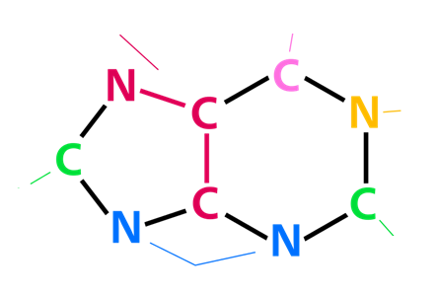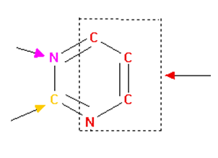
- Draw a scheme of the synthesis of purine and pyrimidine nucleotides. What different in the synthesis purines and pyrimidines?
- What is the end product of purine biosynthesis? How are di- and triphosphates formed?
- Why is folic acid needed for nucleotide synthesis?
- How nucleotide synthesis is regulated? Complete the table:
 | Purine nucleotides | Pyrimidine nucleotides
Activator
Inhibitor

- Degradation of nucleotides
- How are purines degraded? What is the final product of purine degradation in humans?
Draw degradation of AMP to uric acid.
- What are the end product of pyrimidine catabolism?
Draw a scheme of the catabolism of pyrimidine nucleotides.

- Salvage
- What is salvage pathway? What substances are used for the formation of nucleotides in the salvage pathway?
- What does an enzyme phosphoribosyltransferase (APRT) do?
- What does an enzyme hypoxanthine-guanine phosphoribosyltransferase (HGPRT) do?

- Pathology
- What leads to overproduction of purines?
- What causes an overproduction of uric acid?
- What are the disorders of purine metabolism?
- What is the main cause of gout? What are the 10 foods that trigger gout? What drugs raise uric acid levels? What is used to treat gout?
- What violations can be in the path of salvation? What is Lesch-Nyhan Syndrome?
- What is orotic aciduria? What causes orotic aciduria? What is used to treat orotic aciduria?

- For the treatment of what diseases you need to modulate of purine and pyrimidine metabolism?

- Situational tasks
- Allopurinol is a drug that used in the treatment of gout. How does allopurinol work?

- Leflunomide, a specific inhibitor of enzyme dihydroorotate dehydrogenase. How does leflunomide affect the immune system?

- Methotrexate is often used as a chemotherapeutic agent to treat patients with leukemia. How does methotrexate work in leukemia? What are the long term effects of methotrexate?

